**Analysis Report: Travel Data Exploration and Analysis**

**Introduction**

This report presents the analysis conducted on the travel dataset stored in the SQLite database travel.sqlite. The dataset comprises multiple tables containing information about aircrafts, airports, boarding passes, bookings, flights, seats, ticket flights, and tickets. The analysis aims to explore the data, perform basic analytics, and investigate the occupancy rates and revenue generation of aircrafts.

**Data Exploration**

**Database Connection and Table Listing**

The analysis starts by establishing a connection to the SQLite database and listing the tables present in the database:

* aircrafts_data
* airports_data
* boarding_passes
* bookings
* flights
* seats
* ticket_flights
* tickets

**Loading and Displaying Data**

Each table was loaded into a Pandas DataFrame, and the first few rows were displayed to understand the structure and contents of the data. Additionally, the column information and the count of null values for each table were printed to identify any data quality issues.

**Basic Analysis**

**Question 1: Planes with More Than 100 Seats**

To determine which planes have more than 100 seats, the number of seats for each aircraft code was retrieved from the seats table. The result showed the count of seats for each aircraft code.

**Question 2: Number of Tickets Booked and Total Amount Earned Over Time**

The analysis involved merging the tickets and bookings tables to track the number of tickets booked and the total amount earned over time. The booking dates were extracted, and the data was grouped by date to count the number of tickets and sum the total amount earned. The results were plotted to visualize the trends.

* **Count of Tickets by Date:** The line plot showed the daily count of tickets booked.
* **Total Amount Earned by Date:** The line plot depicted the daily total amount earned from bookings.

**Question 3: Average Charges for Each Aircraft with Different Fare Conditions**

The average ticket amount for each aircraft code and fare condition was calculated by joining the ticket_flights and flights tables. The results were visualized using a bar plot, showing the average charges for each aircraft code categorized by fare conditions.

**Analyzing Occupancy Rate**

**Question 1: Total Revenue and Average Revenue Per Ticket**

The total revenue and average revenue per ticket for each aircraft code were calculated by joining the ticket_flights and flights tables. The results provided insights into the revenue performance of different aircraft codes.

**Question 2: Average Occupancy Rate per Aircraft**

The average occupancy rate for each aircraft was calculated by joining the boarding_passes and flights tables to get the number of booked seats and the seats table to get the total number of seats per aircraft. The occupancy rate was computed as the ratio of booked seats to total seats for each aircraft code.

**Question 3: Potential Increase in Annual Turnover with Higher Occupancy Rate**

To explore the potential increase in total annual turnover by increasing the occupancy rate by 10%, the current occupancy rates were increased by 10%, and the corresponding total annual turnover was calculated. The analysis showed the increased total annual turnover for each aircraft code if the occupancy rate were 10% higher.

**Conclusion**

The analysis provided valuable insights into the travel data, including the seat capacity of aircrafts, ticket booking trends, revenue generation, and occupancy rates. The investigation of occupancy rates and potential revenue increases highlighted opportunities for optimizing aircraft utilization and maximizing revenue. This report serves as a comprehensive overview of the travel dataset, offering data-driven insights to support decision-making and strategic planning.

**Visualizations**

* **Count of Tickets by Date:** 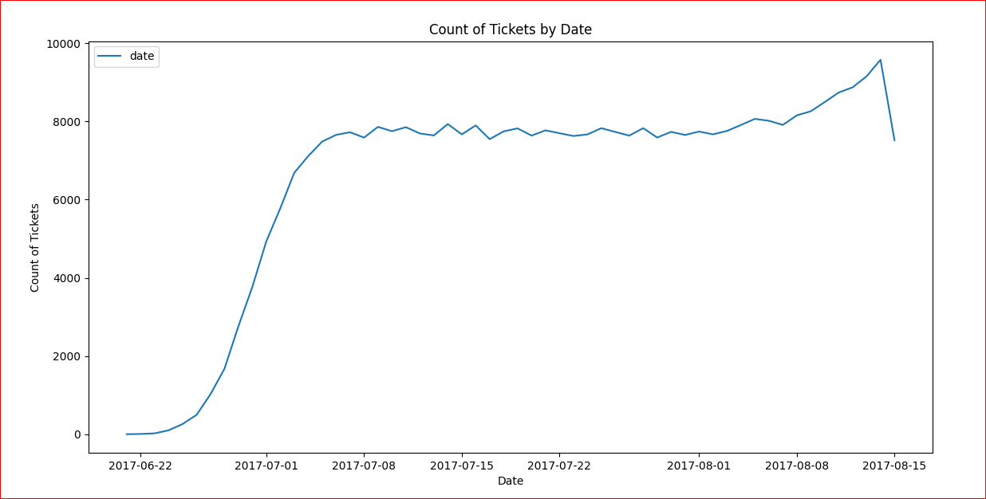
* **Total Amount Earned by Date:**

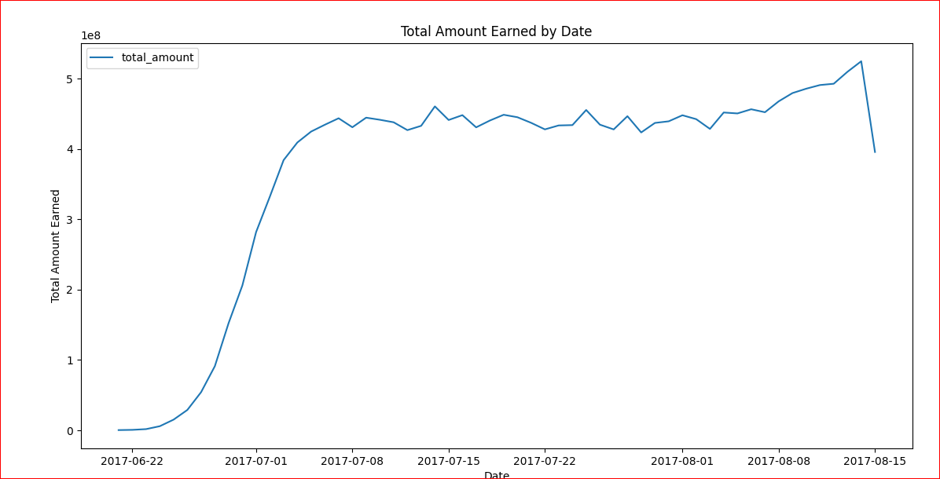

* **Average Charges by Aircraft and Fare Conditions:** 